**DB_Model Class Methods:**

RetrieveSettings:

Stores data received from the database in a ConcurrentDictionary object that is passed in; logs the values of the data received in the log file.

Inputs: string location

string operation

(Reference to) ConcurrentDictionary<string, string> configParams

Returns: true/false (completed successfully/unsuccessfully)

Database Calls:

"Select cfc_setting_name, cfc_setting_value from OPS$DBRED.cryoview_filltube_config where cfc_location = '" + location + "' and cfc_hardware = '" + operation + "'"

RetrieveNextFileId:

Retrieves the next file ID from the database and saves the value to the passed in fileID string.

Inputs: (Reference to) string fileId

Returns: true/false (completed successfully/unsuccessfully)

Database Calls:

"Select OPS$DBRED.CRYO_FILLTUBE_FILE_ID.nextval from dual"

**Dependency diagrams for database connections:**

Objects dependent on DB_Model:

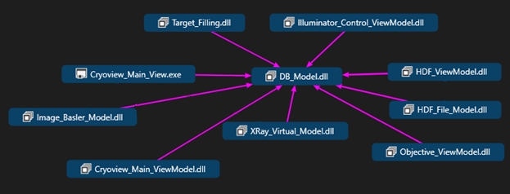

Target_Filling:

Calls RetrieveSettings

Illuminator_Control_ViewModel:

Calls RetrieveSettings

HDF_ViewModel:

Calls RetrieveSettings

Calls RetrieveNextFileId

HDF_File_Model:

Calls RetrieveSettings

Objective_ViewModel:

Calls RetrieveSettings

XRay_Virtual_Model:

Calls RetrieveSettings

Cryoview_Main_ViewModel:

Calls RetrieveSettings

Image_Basler_Model:

Calls RetrieveSettings

Cryoview_Main_View:

Calls RetrieveSettings

Objects DB_Model is dependent on:

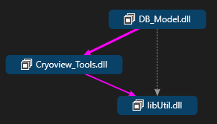

DB_Model makes calls to Cryoview_Tools to log the data pulled from the database by its RetrieveSettings method. Log levels, which determine what gets logged, are a part of libUtil.

Future Changes:

Adding more hardware classes which will use the RetrieveSettings method.

Tables and access methods for storing and retrieving calibration curve data (What data is stored in this table?)

Creating new methods to query other tables for target information (What target information other than target ID needs to be stored and retrieved?)

Creating new methods to store data in the tables for target and layering data. (What data will be written to the tables?)

Will hardware settings be written to the database or just the HDF files?